**TUNE IN – A musical website**

**Introduction:**

An online shopping portal named “Tune In”. This portal is a place to hear your favorite songs as well as to shop for various music related products such as Albums, Electronics and Merchandise.

**Contents:**

The portal contains the following factors:

* Sign up
* Login
* Home page
  + 1. About us
    2. Albums 🡪 (Songs)
    3. Electronics
    4. Merchandise 🡪 (Shop)
    5. Admin panel
    6. Feedback form
* Billing page
  + 1. Pdf generation
* Database
  + 1. Sign in
    2. Billing
    3. Feedback

1.php -**(signup)**

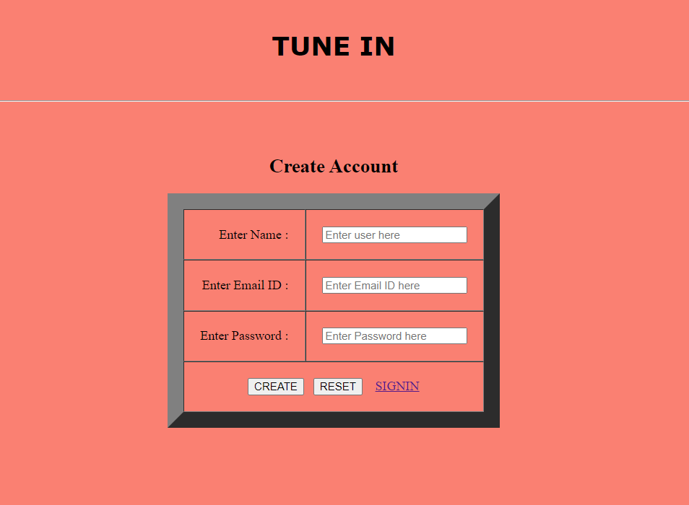

3.php -**(signin)**

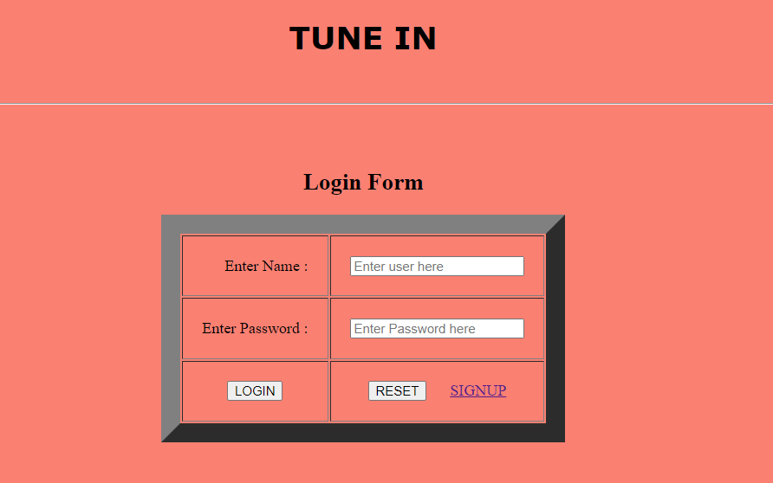

Homepage.php - **(Home page)**

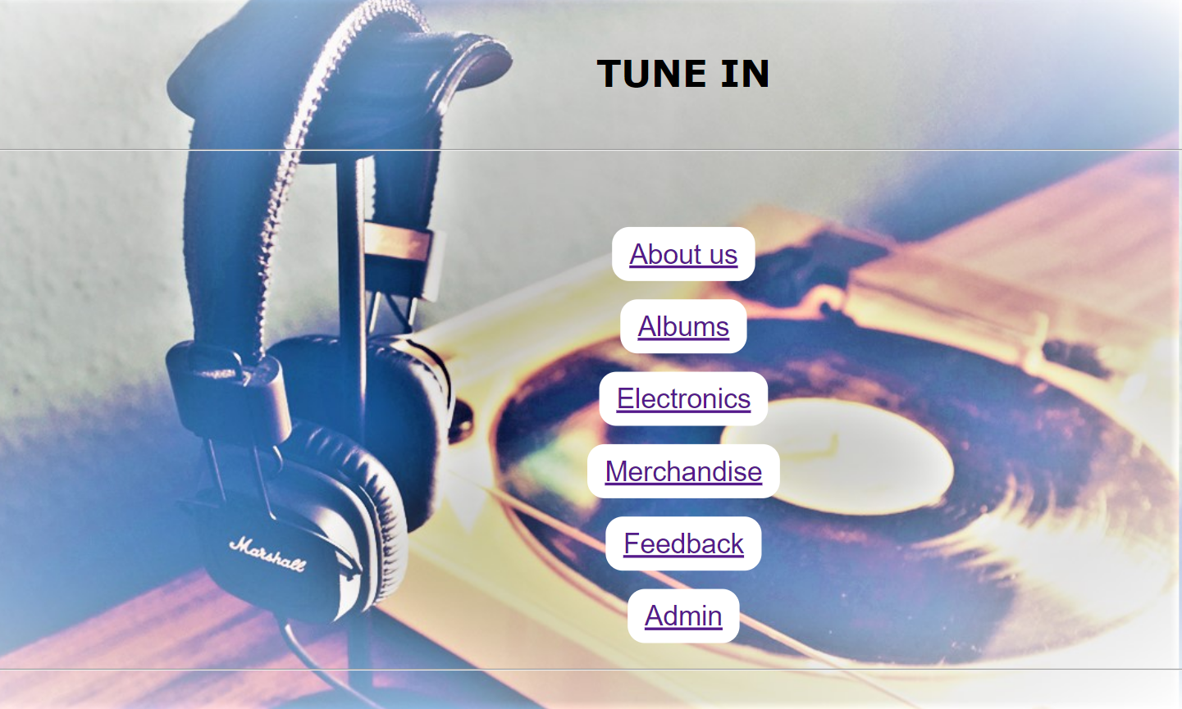

About us.php **- (About us)**

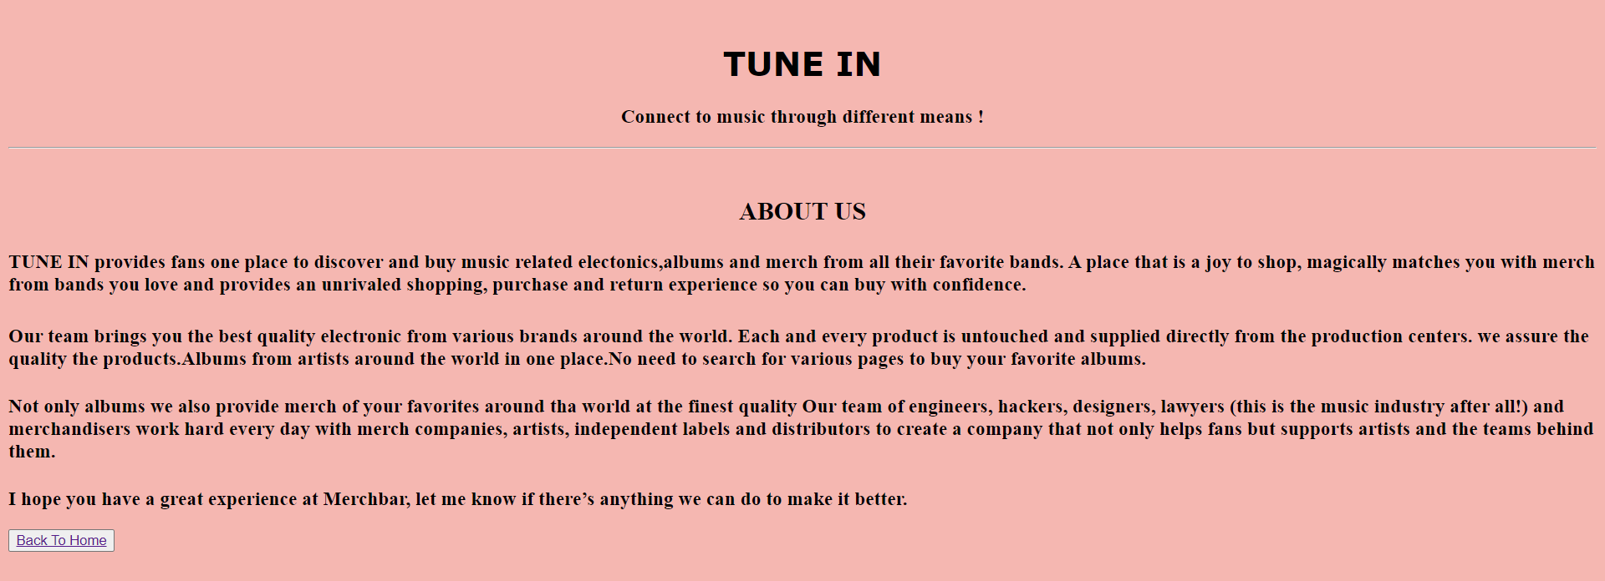

Albums.php **– (Albums)**

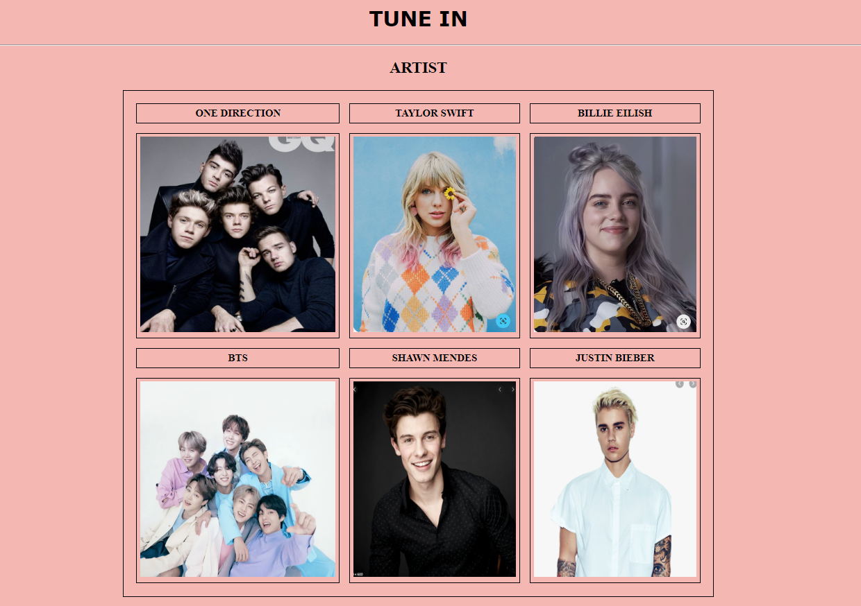

Album-One direction.php

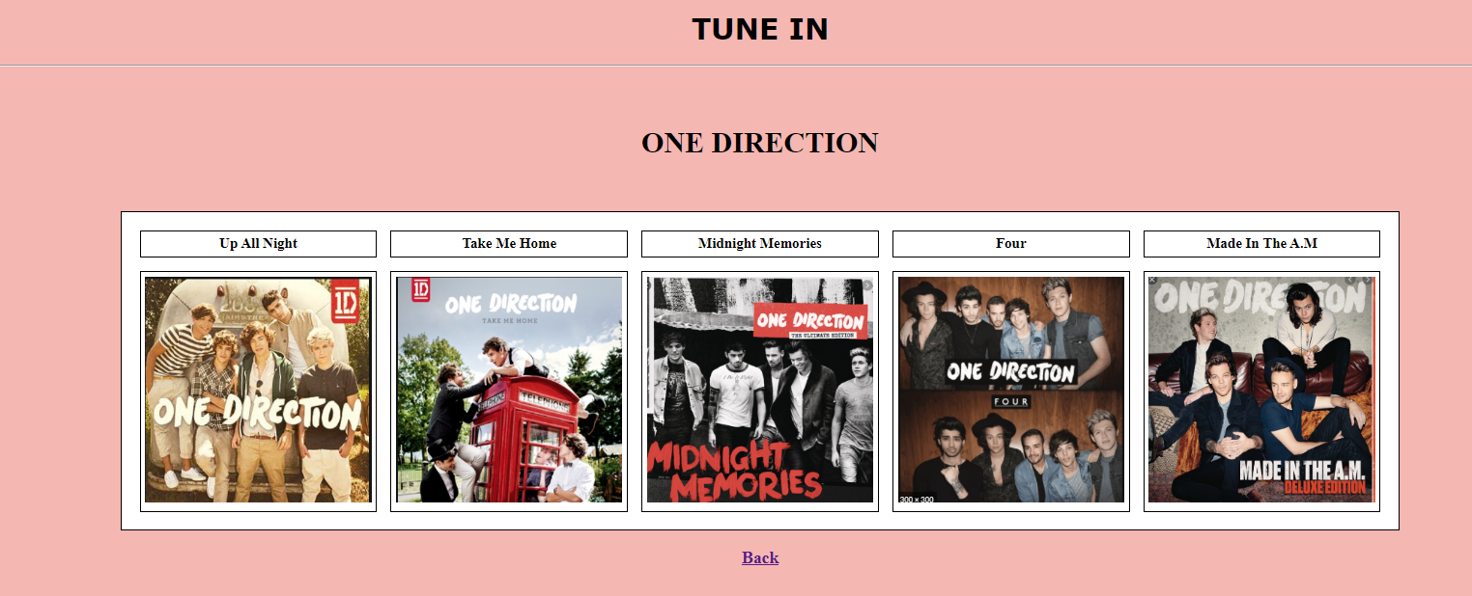

One direction-up all night.php

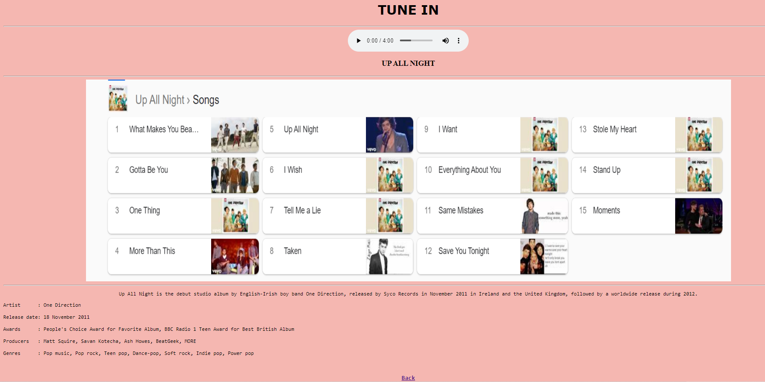

Album-Taylor swift.php

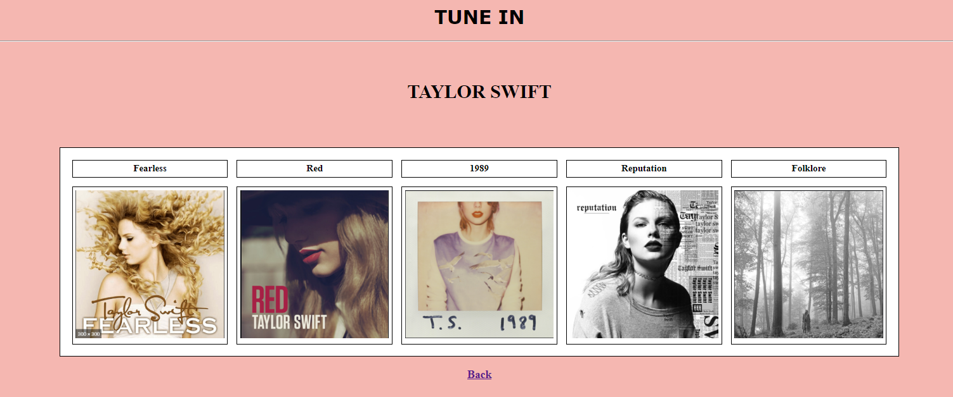

Taylor-Fearless.php

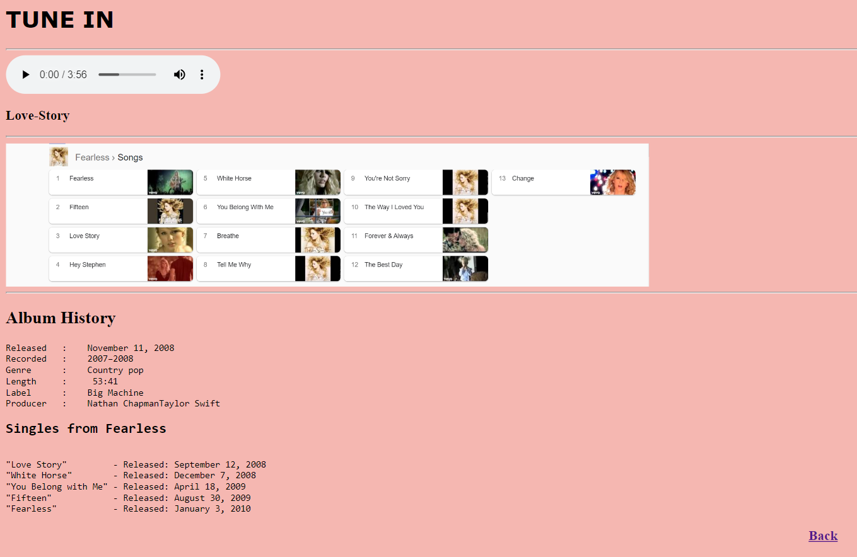

Album-Bille eilish.php

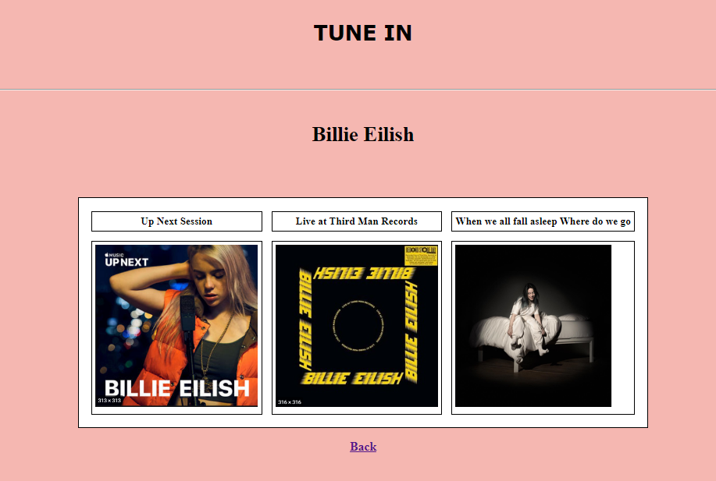

Album -BTS.php

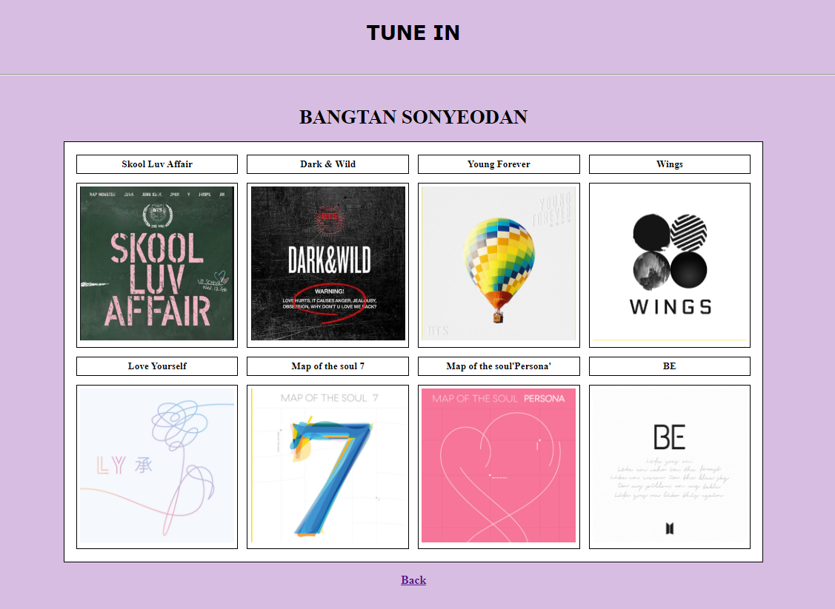

Album-shawn mendes.php

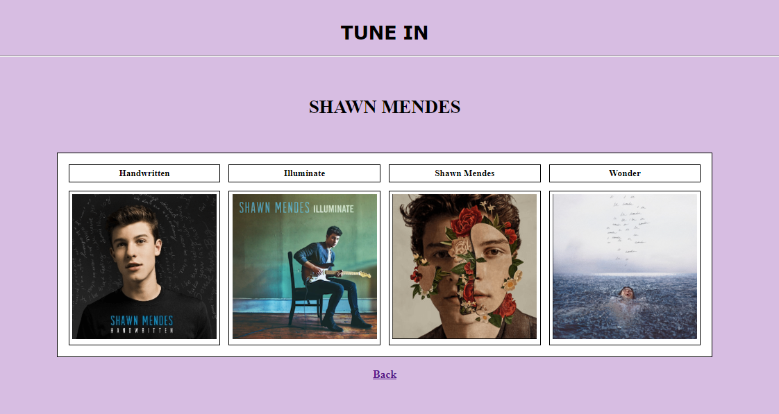

Album-Justin.php

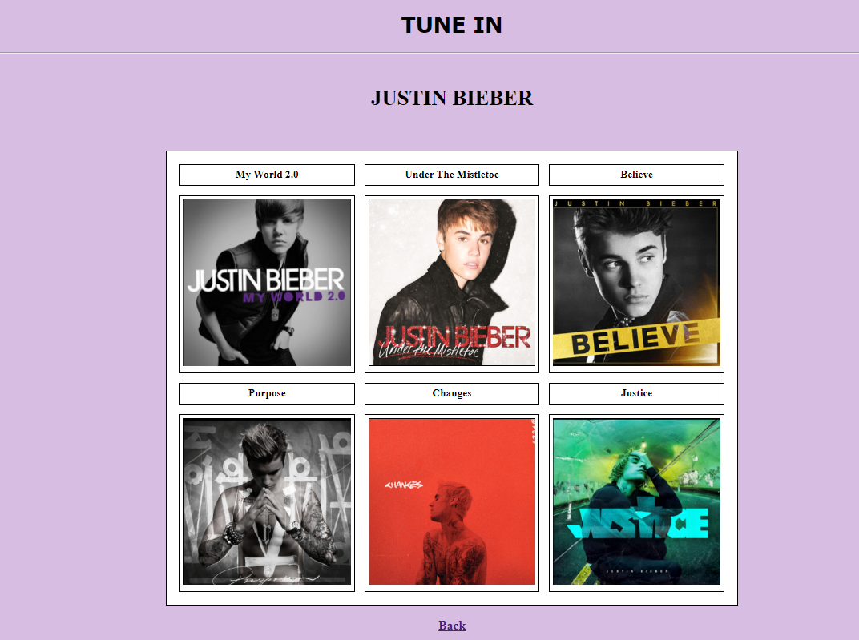

Electronics.php – **(Electronics)**

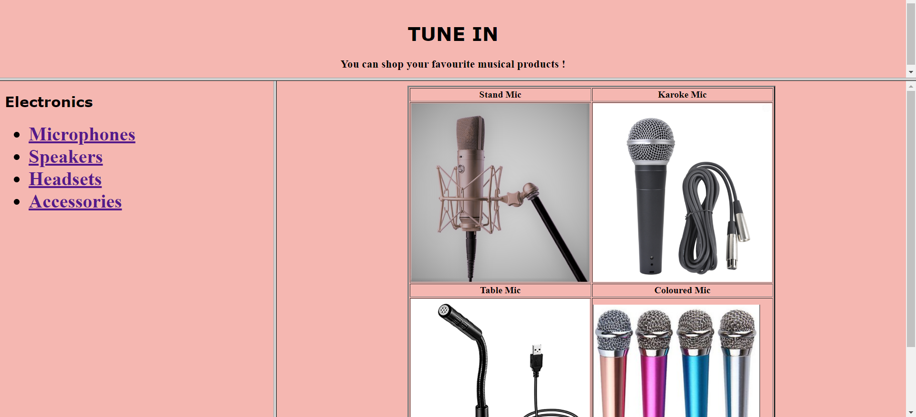

Mic 1.php

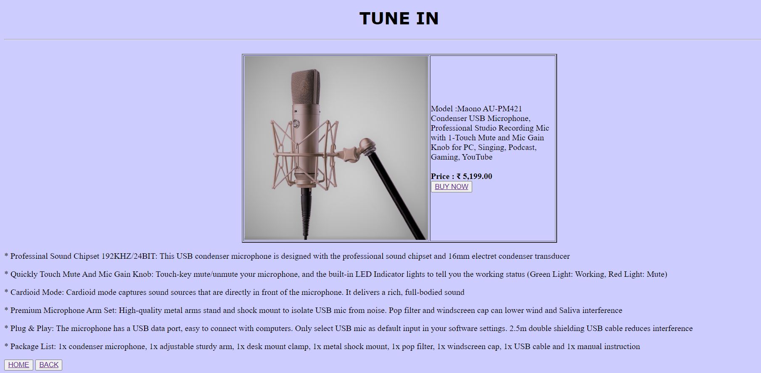

5.php(Billing page)

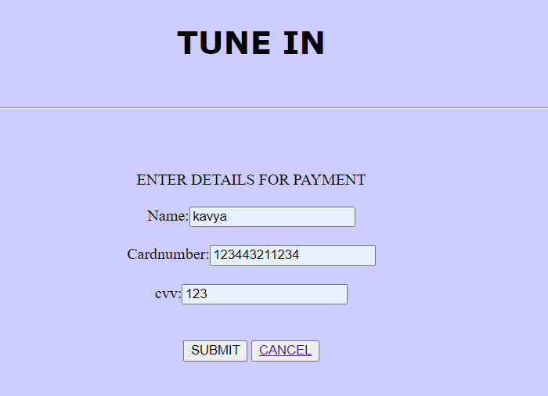

form.php(pdf generation)

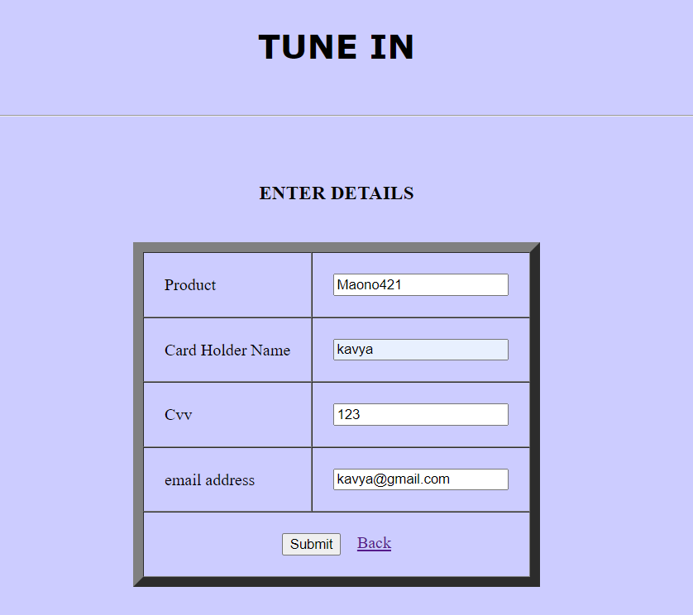

Bill Pdf format:



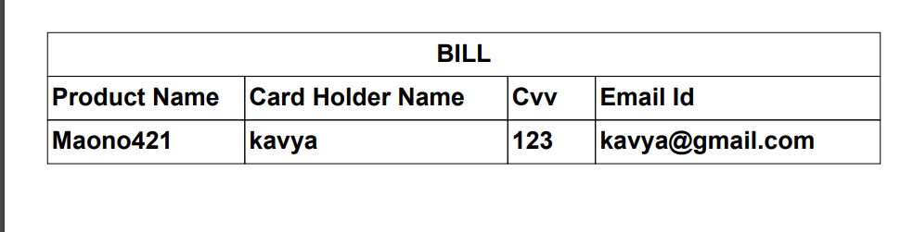

Merchandise.php – **(Merchandise)**

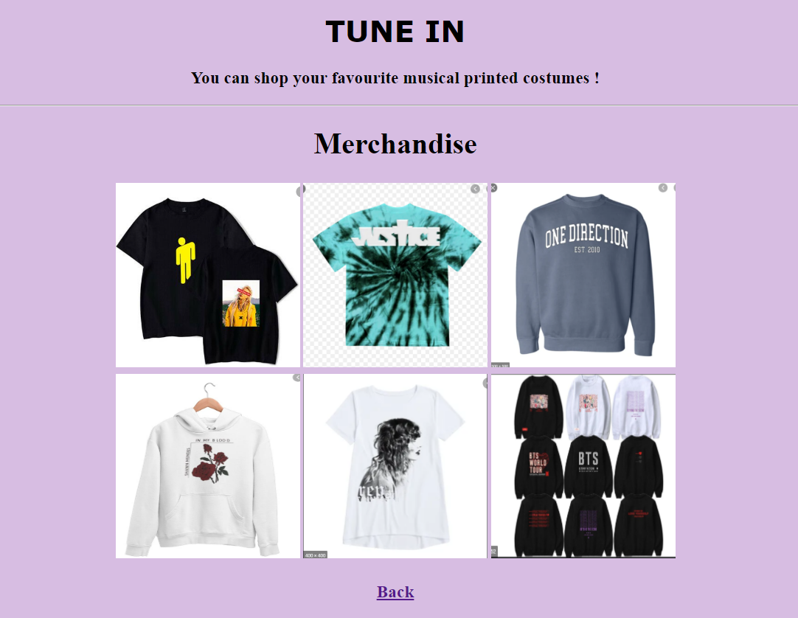

Feedback.php **– (Feedback form)**

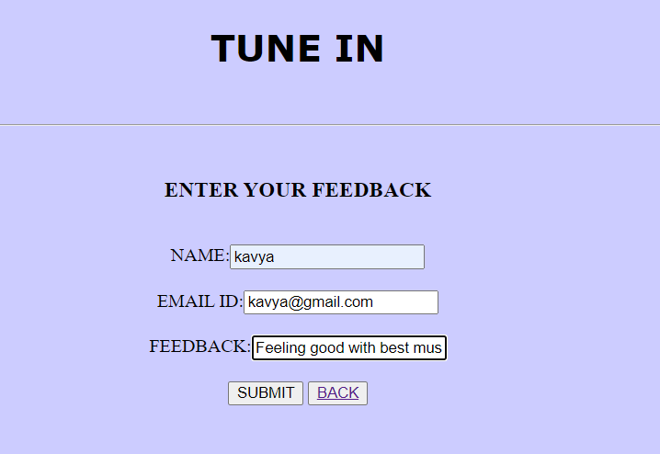

thankyou.php

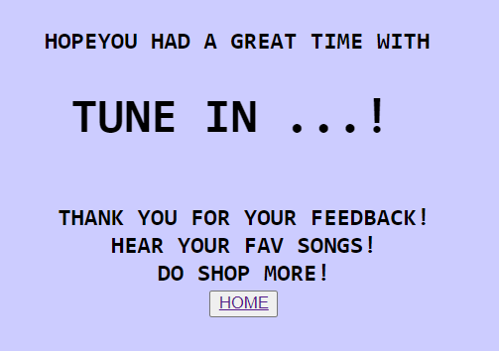

Admin panel.php **- (Admin panel)**

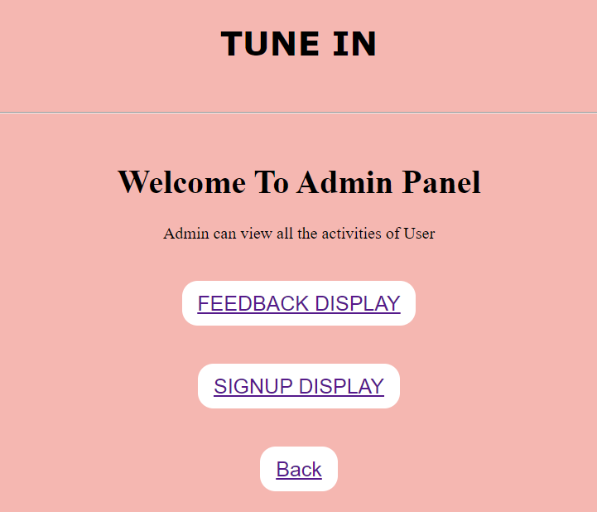

feedbackdisplay.php

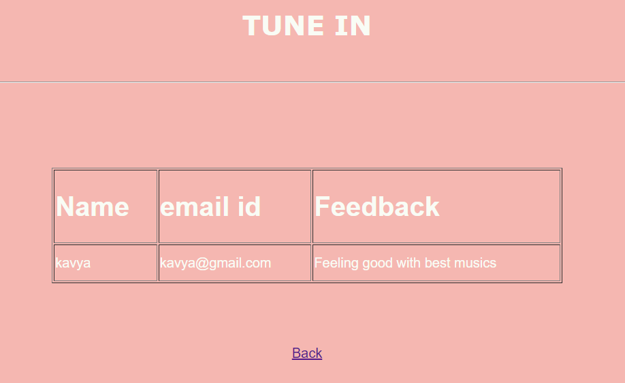

Signupdisplay.php

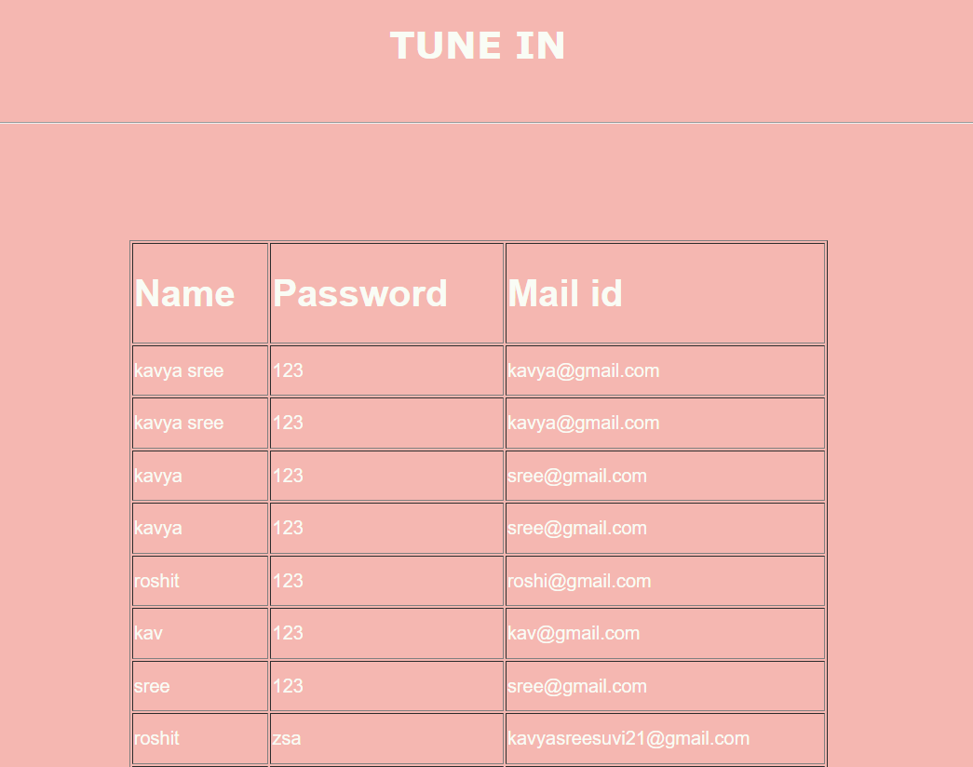

**DATABASE:**

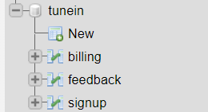

**billing**

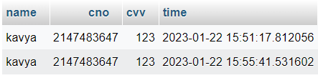

**feedback**

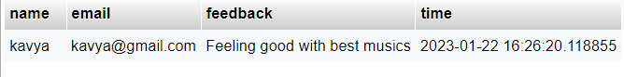

**signup**

